**World Quant University**

**Professor Steven Stelk**

**Financial Markets II**

**Final Project**

Nikolas Lippmann Pareschi - [nikolaslippmann@gmail.com](mailto:nikolaslippmann@gmail.com)

In the first question we are asked to calculate current stock price using the Dividend Discount Model considering:

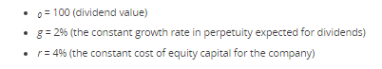

We need to apply the following formula:

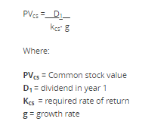

Considering that:



So we have D1 = 100(1+0,02) = 102

And Value of Stock = 102 / (0,04-0,02) = 5100

The calculations are in the excel file also.

In the second question we are asked to implement the Single-Index Model for pricing IBM stock considering the market index as the S&P 500.

We have downloaded the data from Yahoo Finance. The question was silent about the risk free rate, so I picked a random number that made sense: 0.2% monthly. We calculated the monthly excess returns for SP500 and IBM considering the risk free rate:

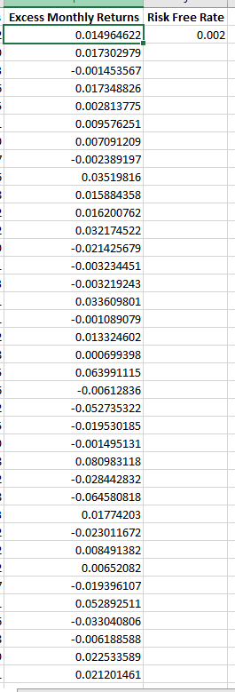 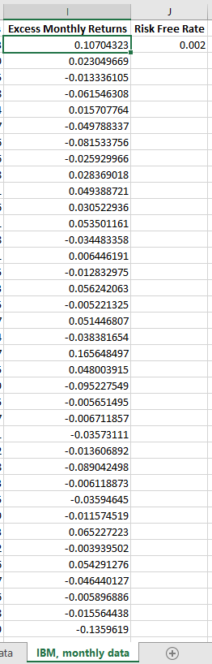

We then applied the data analysis tool to find the regression equation for this data considering y the IBM excess return values and X (independent variable) the SP500 excess returns values. We have found:

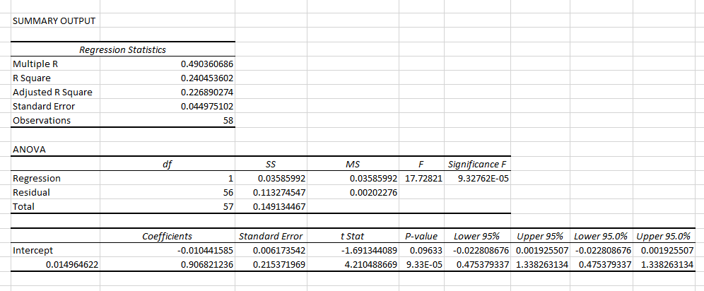

We have a Beta of 0.9068 and an alpha of -0.010. We have a p-value above 5% for the alpha so we cannot sustain within the 95% interval of confidence that there is a real (even negative) alpha in IBM stock. Nevertheless, we have a close to zero p-value for the Beta, so it is highly likely true that the returns are explained by the independent variable. Despite this fact we have a R Square of 0.24, the interpretation is that only 24% of the IBM’s variations are explained by the SP500.

The graph below summarize our findings:

In the third question we are asked to implement the Black-Scholes model for pricing an option on commodity futures and then compute the call option price and put option price considering:

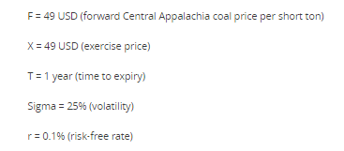

We cannot blindly apply the Black Scholes Model, we have to adapt the S in the formula to be F, where F is the future price. Making that adaptation we have:

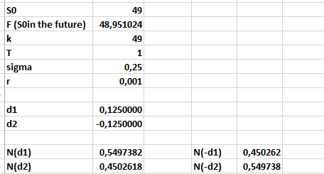

The call option price for the data above is: 

The put option price for the data above is: 

Which makes sense because when the futures price = exercise price then calls and puts must have the same value by definition.

Next we are asked to:



Considering that data we have:



